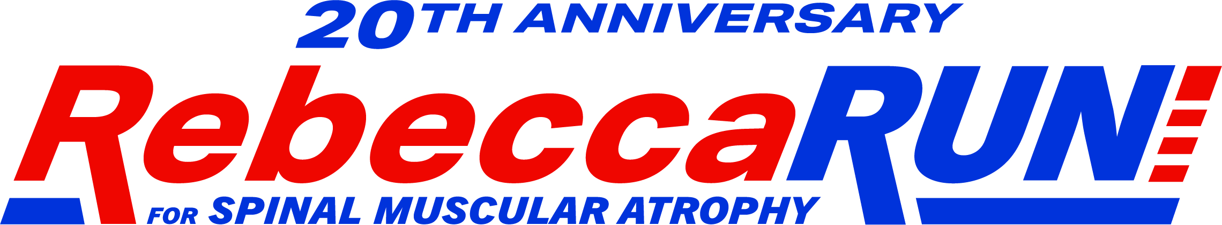
PLEDGE FORM

Participant Information Required

LAST NAME
FIRST NAME
ADDRESS
CITY PROV POSTAL CODE
TELEPHONE EMAIL
NAMADDRESS (street, city, province, postal code) PHONE AND E-MAIL

PLEDGES - Please print clearly and include full mailing address including postal code.

If the information is incomplete, no tax receipt will be able to be issued.

NAME | ADDRESS | Cash/Cheque Total
 |  | $
TOTAL

Page ___ of _____

Please make cheques out to: Cure SMA Canada
Copy this page if you need more space. and 14th at an
All donations are tax-deductible. Registered charitable #: 84178 1685 RR0001

Cure SMA Canada values your support

